**Global Malnutrition Trends: A Power BI Analysis (1983-2019)**

**Introduction:**

This project aims to analyze **global malnutrition trends from 1983 to 2019** using Power BI. By leveraging data visualization techniques, the project will provide insights into **severe wasting, wasting, stunting, underweight, and overweight conditions** among children under five years of age across different countries. The analysis categorizes countries based on **income levels (low, lower-middle, upper-middle, and high income)** and classifications such as **Least Developed Countries (LDC), Low-Income Food Deficient (LIFD), Land Locked Developing Countries (LLDC), and Small Island Developing States (SIDS)** to examine the correlation between economic status and malnutrition rates.

The analysis will enable stakeholders to identify **patterns and trends in child malnutrition**, highlighting **regions most affected and requiring urgent intervention**. Through rigorous examination of malnutrition prevalence, economic factors, and historical data, stakeholders will gain **actionable insights to support policy-making and resource allocation**. Ultimately, the goal is to empower decision-makers with **data-driven strategies** to combat child malnutrition and improve health outcomes globally.

**Scenario 1: Count of U5 Population (140)**

A research organization wants to analyze the number of observations related to the **under-five (U5) population** in a global malnutrition dataset. By using **Power BI**, they can track **140 data points** collected over time, helping them assess the dataset's coverage and reliability. This metric is crucial in ensuring that the study encompasses a sufficient sample size for accurate insights into child malnutrition trends.

**Scenario 2: Sum of Survey Sample (11M)**

A health agency is conducting a large-scale survey to assess child malnutrition trends. They utilize **Power BI** to analyze the **11 million survey samples**, ensuring that findings are statistically robust. With interactive dashboards, they can filter the data based on regions, time periods, or malnutrition types, allowing policymakers to **derive meaningful insights and allocate resources efficiently**.

**Scenario 3: Sum of Underweight (2.08K)**

A nutrition-focused NGO is examining the prevalence of **underweight cases** among children under five. Using **Power BI**, they analyze a total of **2,080 underweight cases**, identifying regions where underweight conditions are most prevalent. This enables them to **target interventions, allocate funding, and implement nutrition programs** where they are needed most.

**Scenario 4: Sum of LDC,LIFD,LLDC or SID2 and Average of Stunting by Income Analysis**

A global health organization is investigating how income levels impact child stunting rates. By visualizing **Least Developed Countries (LDC), Low-Income Food Deficient (LIFD), Land Locked Developing Countries (LLDC), and Small Island Developing States (SIDS)** data in **Power BI**, they observe that as **income levels rise, average spending on nutrition also increases**. This insight helps governments and NGOs **design economic policies and nutrition aid programs** to combat stunting.

**Scenario 5: Sum of Overweight by Country**

A public health department is assessing the burden of **childhood overweight cases** across different countries. With **Power BI**, they create a visualization that highlights the **total number of overweight children per country**, allowing policymakers to **identify hotspots of rising childhood obesity**. This data helps in formulating **targeted interventions, public health awareness campaigns, and improved dietary guidelines**.

**Scenario 6: Sum of Overweight and Underweight under Income Classification.**

An international research team is analyzing how **income levels influence both overweight and underweight conditions** in children under five. Using **Power BI's ribbon charts**, they observe how the relative proportions of **overweight and underweight cases** shift across different income brackets. This insight helps in understanding the **dual burden of malnutrition** and enables **governments and health agencies to tailor their nutrition strategies** accordingly.

**Scenario 7: Sum of Income Classification**

A policymaker wants to examine the **total income within each income bracket** to understand its relation to malnutrition. By leveraging **Power BI**, they analyze how income is distributed across different groups, revealing disparities that may contribute to malnutrition. These insights support **data-driven decision-making in economic policies and social welfare programs** to **reduce child malnutrition rates globally**.

**Technical Architecture:**

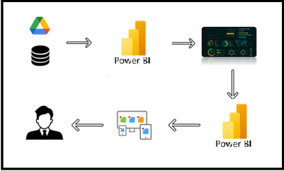

**Project Flow**

To accomplish this, we have to complete all the activities listed below,

* Data Collection
  + Collect the dataset,
  + Connect Data with Power BI
* Data Preparation
  + Prepare the Data for Visualization
* Data Visualizations
  + No of unique Visualizations
* Dashboard
  + Responsive and Design of Dashboard
* Report
* Report Creation
* Performance Testing
  + Utilization of Data Filters
  + No. of Calculation fields
  + No. of Visualizations/Graphs
* Project Demonstration & Documentation
  + Record explanation Video for project end to end solution
  + Project Documentation-Step by step project development procedure

**Milestone 1: Data Collection & Extraction from Database**

Data collection is the process of gathering and measuring information on variables of interest, in an established systematic fashion that enables one to answer stated research questions, test hypotheses, evaluate outcomes and generate insights from the data.

**Activity 1: Downloading the dataset**

Please use the link to download the dataset: [Link](https://www.kaggle.com/datasets/ruchi798/malnutrition-across-the-globe?select=malnutrition-estimates.csv)

**Activity 1.1: Understand the data**

Data contains all the meta information regarding the columns described in the CSV files

**Column Description of the Dataset:**

* **ISO code:** Standardized two-letter country codes.
* **Country:** Name of the country.
* **Survey Year:** The year in which the survey data was collected.
* **Year:** The specific year of the data point.
* **Income Classification:** Income classification of countries (0: Low Income, 1: Lower Middle Income, 2: Upper Middle Income, 3: High Income).
* **LDC:** Indicator for Least Developed Countries (LDCs).
* **LIFD:** Indicator for Low Income Food Deficient (LIFD) countries.
* **LLDC or SID2:** Classification for Land Locked Developing Countries (1), Small Island Developing States (2), and Others (0).
* **Survey Sample (N):** The size of the survey sample.
* **Severe Wasting:** Average percentage of children with severe wasting.
* **Wasting:** Average percentage of children with wasting.
* **Overweight:** Average percentage of overweight children.
* **Stunting:** Average percentage of children with stunting.
* **Underweight:** Average percentage of underweight children.
* **U5 Population ('000s):** Population of children under five years old (in thousands).

**Milestone 2: Data Preparation**

Data preparation is a critical phase in the data lifecycle, encompassing activities that transform raw data into a format suitable for analysis. This multifaceted process involves several steps including data cleaning, integration, transformation, and enrichment. Data cleaning involves identifying and rectifying errors, inconsistencies, and missing values within datasets to ensure accuracy and reliability.

**Activity 1: Prepare the Data for Visualization**

Preparing the data for visualization involves cleaning the data to remove irrelevant or missing data, transforming the data into a format that can be easily visualized, exploring the data to identify patterns and trends, filtering the data to focus on specific subsets of data, preparing the data for visualization software, and ensuring the data is accurate and complete. This process helps to make the data easily understandable and ready for creating visualizations to gain insights into the performance and efficiency.

3.1: Data Loading

**Explanation video link:**

**[https://drive.google.com/file/d/1mAWW0WmNnq_hP3WY3MmXpFDBRZcdQ6K/view?usp=drive_link](https://drive.google.com/file/d/1mAWW0WmNnq_hP3WY3Mm-XpFDBRZcdQ6K/view?usp=drive_link)**

3.2 Data Cleaning

**Explanation video link:**

**[https://drive.google.com/file/d/1ShADsW7pIapq4KpEoAeX30v4dDQwBEP/view?usp=drive_link](https://drive.google.com/file/d/1ShADsW7pIapq4KpEoAeX30v-4dDQwBEP/view?usp=drive_link)**

**Milestone 3: Data Visualization**

Data visualization is the process of creating graphical representations of data to help people understand and explore the information. The goal of data visualization is to make complex data sets more accessible, intuitive, and easier to interpret. By using visual elements such as charts, graphs, and maps, data visualizations can help people quickly identify patterns, trends, and outliers in the data.

**Activity 1: Global Malnutrition Trends(1983-2019)**

**Activity 1.1: Count of U5 Population**

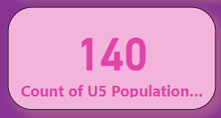

**Activity 1.2: Sum of Survey Sample**

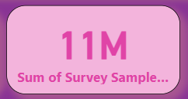

**Activity 1.3: Sum of Underweight**

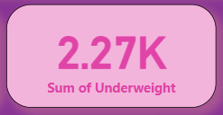

**Activity 1.4: Sum of LDC,LIFD,LLDC or SID2 and Average of Stunting by Income Analysis**

**\*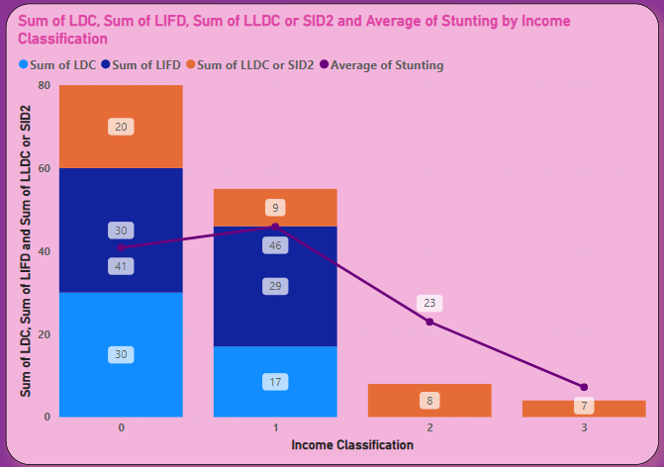**

**Activity 1.5: Sum of Overweight by Country**

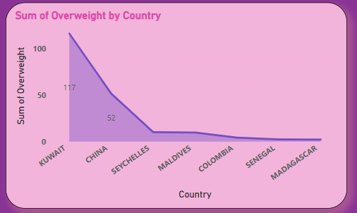

**Activity 1.6: Sum of Overweight and Underweight under Income Classification.**

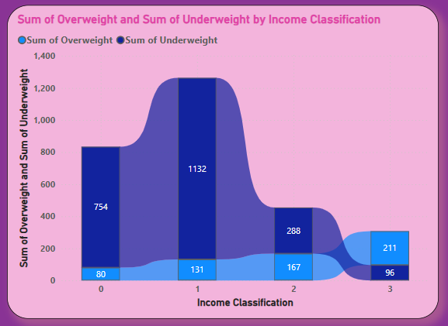

**Activity 1.7: Sum of Income Classification**

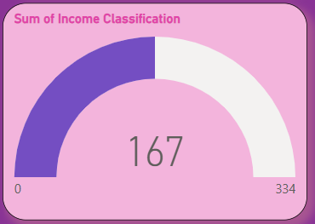

**Milestone 4: Dashboard**

A dashboard is a graphical user interface (GUI) that displays information and data in an organized, easy-to-read format. Dashboards are often used to provide real-time monitoring and analysis of data and are typically designed for a specific purpose or use case. Dashboards can be used in a variety of settings, such as business, finance, manufacturing, healthcare, and many other industries. They can be used to track key performance indicators (KPIs), monitor performance metrics, and display data in the form of charts, graphs, and tables.

**Activity 1- Responsive and Design of Dashboard**

The responsiveness and design of a dashboard is crucial to ensure that the information is easily understandable and actionable. Key considerations for designing a responsive and effective dashboard include user-centred design, clear and concise information, interactivity, data-driven approach, accessibility, customization, and security. The goal is to create a dashboard that is user-friendly, interactive, and data-driven, providing actionable insights to improve the performance and efficiency.

**Explanation video link:**

[**https://drive.google.com/file/d/1TWPDWC1sSP5Q1CV_elVyS2C3dGdWcXDo/view?usp=drive_link**](https://drive.google.com/file/d/1TWPDWC1sSP5Q1CV_elVyS2C3dGdWcXDo/view?usp=drive_link)

**Dashboard:**

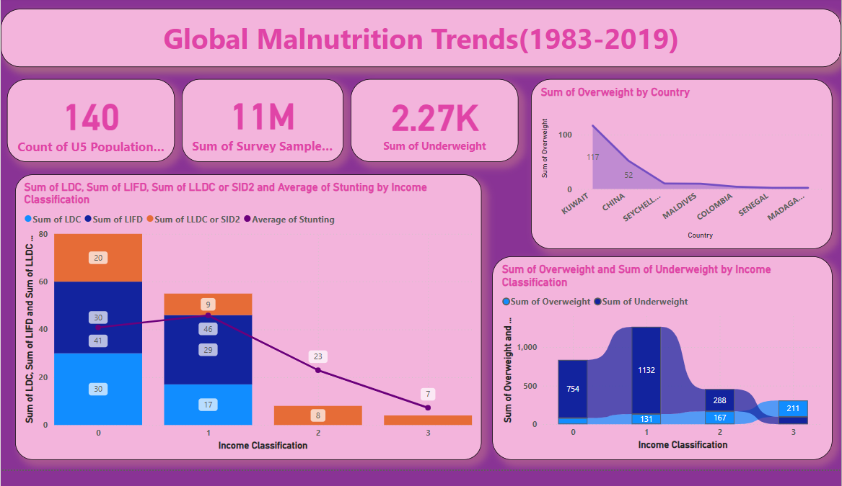

**Milestone 5: Report**

A data report is a way of presenting data and analysis in a narrative format, with the goal of making the information more engaging and easier to understand. A data story typically includes a clear introduction that sets the stage and explains the context for the data, a body that presents the data and analysis in a logical and systematic way, and a conclusion that summarizes the key findings and highlights their implications. Data Report can be told using a variety of mediums, presentations, interactive visualizations, and videos.

**Activity 1: Design of Report**

Designing a report in Power BI involves connecting to data sources, creating visualizations like charts and graphs, customizing their appearance and interactivity, organizing them logically on the canvas, formatting elements for consistency and clarity, and optionally creating dashboards for a summarized view. Throughout the process, it's essential to consider the audience's needs and ensure the report effectively communicates insights from the data. Finally, iterate based on feedback to continually improve the report's design and usefulness.

**Explanation video link:**

[**https://drive.google.com/file/d/1BWGjyKx5lIv7sKg4uGaorCuOYAt74SwE/view?usp=drive_link**](https://drive.google.com/file/d/1BWGjyKx5lIv7sKg4uGaorCuOYAt74SwE/view?usp=drive_link)

**Report:**

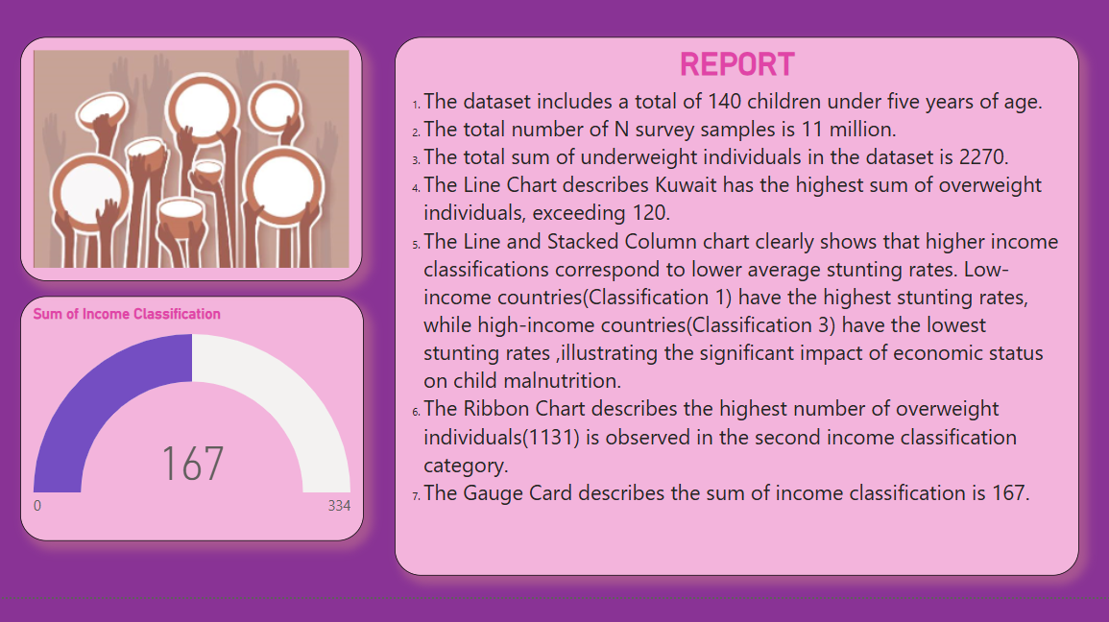

**Milestone 6: Performance Testing**

Performance testing is a crucial aspect of software development aimed at evaluating the speed, responsiveness, stability, and scalability of an application under various workload conditions. It involves simulating real-world usage scenarios to assess how the system behaves and performs under stress, peak loads, or normal conditions.

**Activity 1: Amount of Data Loaded**

"Amount of Data Loaded" refers to the quantity or volume of data that has been imported, retrieved, or loaded into a system, software application, database, or any other data storage or processing environment. It's a measure of how much data has been successfully processed and made available for analysis, manipulation, or use within the system.

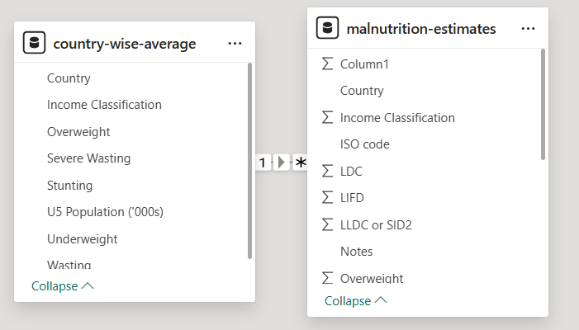

**Activity 2: Utilization of Filters**

The utilization of data filters plays a pivotal role in streamlining information processing and analysis across various domains. By selectively extracting or excluding specific data points based on predefined criteria, filters enable efficient data management and enhance decision-making processes.

**Activity 2.1: Selected “Country” as a Filter**

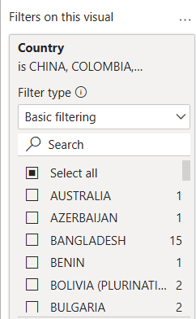

**Activity 3: No of Visualizations/ Graphs**

1. Count of U5 Population
2. Sum of Survey Sample(N)
3. Sum of Underweight
4. Sum of Overweight by Country
5. Total Income Classification
6. Sum of Overweight and Underweight by Income Classification
7. Sum of LDC, LIFD, LLDC or SID2 and Average of Stunting by Income Analysis

**Milestone 7: Project Demonstration & Documentation**

Below mentioned deliverables to be submitted along with other deliverables

**Activity 1: - Record explanation Video for the project's end-to-end solution**

Creating a record explanation video for a project's end-to-end solution is crucial for ensuring clarity and transparency in its implementation. This video serves as a comprehensive guide, detailing every aspect of the project from inception to completion.

**Activity 2: - Project Documentation-Step by step project development procedure**

Create document as per the template provided